EMERGING METHODS FOR EARLY FOREST FIRE DETECTION

## IBM PROJECT REPORT

***Submitted by***

**M.K.SOUNDARI 142219205090**

**M.P.SRIJA 142219205093**

**B.VARALAKSHMI 142219205103**

**G.VIJAYALAKSHMI 142219205107**

***in the partial fulfillment for the award of the degree of***

**BACHELOR OF TECHNOLOGY**

## IN

## INFORMATION TECHNOLOGY

**SRM VALLIAMMAI ENGINEERING COLLEGE, CHENGALPATTU**

**ANNA UNIVERSITY :: CHENNAI 600 025**

**NOVEMBER 2022**

# ABSTRACT:

Forest fires are very dangerous. Fire outbreaks are a typical occurrence all throughout the world, and the harm they bring to both nature and humans is enormous. In comparison to classic sensor-based fire detection systems, vision-based fire detection systems have recently gained favour. Once they become disasters, it is very difficult to extinguish. In this paper, convolutional neural network based forest fire detection approach is proposed. Firstly, the local binary pattern feature extraction and classifier are used for smoke detection, so as to make a preliminary discrimination of forest fire. In order to accurately identify it in the early stage of the fire, according to the convolutional neural network (CNN), it has the characteristics of reducing the number of parameters and improving the training performance through local receptive domain, weight sharing and pooling. This paper proposes another method for detecting forest fires in convolutional neural networks. Image preprocessing operations such as histogram equalization and smooth low-pass filtering are performed prior to inserting the image into the CNN network. The effectiveness of the proposed method is verified by detecting real forest fire images. We designed a Convolutional Neural Network-based fire detection technique. Through training with datasets, obtain high-accuracy fire image detection that is consistent with fire detection. This paper critically analyzes the scope of Artificial intelligence for detection with video from CCTV footages. This project uses dataset containing video frames with fire. The data is then preprocessed and use the CNN to build a model to detect fire. The dataset is given as input for validating the algorithm and experiments are noted. This project focus on building high accuracy and cost efficient machine that can be used for fire detection. These images from footage were created using fire-related video and some images found on the internet. The images have been scaled and reshaped to convert to a training dataset and converted to a testing dataset. Convolution, activation functions, and the max pooling technique are used to train the model. The model is trained by varying batch sizes and epoch values. As a result, we obtain a high accuracy and detection rate.

**Key words:** CNN, fire detection, machine learning.

## INTRODUCTION:

Fire can make major hazards in this world. It is very harmful when a fire occurs in a forest. Sometimes, it could not be possible to stop the fire. Forests are one of the main factors in balancing the ecology. The elements in the forest encourage the fire when it starts. Once fire starts, it will remain until it distinguished completely. The damage and the cost for distinguish fire because of forest fire can be reduced when the fire detected early as possible. Thus, the function of fire detection is crucial for people's safety. Several fire detection techniques have been created to prevent fire-related harm. Various technical solutions are available. The majority of them rely on sensors, which are mainly limited to indoor use. However, those approaches have a fatal fault in that they will only work if a specific condition is met. In the worst-case scenario, the sensors are damaged or not being configured properly can cause heavy casualty in case of real fire, resulting in significant casualties in the event of a genuine fire. These sensors use ionisation to detect particles created by smoke and fire, which requires close proximity to the fire. As a result, they can't be used to cover big areas. Video fire detection systems are used to overcome such limitations. As digital cameras and video processing technology advance, there is a substantial tendency to move to new technologies. To get over such limitations video fire detection systems are used. Due to rapid developments in digital cameras and video processing techniques, there is a significant tendency to switch to traditional fire detection methods with computer vision based systems. Video-based fire detection techniques are well suited for detecting fire in large and open spaces. Nowadays, closed circuit television surveillance systems are installed in most of the places monitoring indoors and outdoors. Under this circumstance, it would be an advantage to develop a video-based fire detection system, which could use these existing surveillance cameras without spending any extra cost. This type of systems offers various advantages over those standard detection methods. For example, the cost of using this type of detection is cheaper and the implementation of this type system is greatly simpler compare to those traditional methods. Secondly, fire detection system responds faster compared to any other traditional detection methods because a vision based fire detection system does not require any type conditions to trigger the devices and it has the ability to monitor a large area. Even experts in the field will be unable to provide a single or a collection of highlights with great precision under a variety of conditions. Highlight learning emerged as a result of this issue. The necessary pieces for working with images are naturally advanced. In view of the CNN model’s reasonable accuracy for fire detection, its size, and the rate of false alarms, the system can be helpful to disaster management teams in controlling fire disasters in a short time. Thus, avoiding huge losses. This work mainly focuses on the detection of fire scenes under observation.

A competitive advantage in developing a video-based fire detection system ,This could make advantage of the surveillance cameras already in place without paying additional costs. Compared to traditional detection approaches, this type of technology has several advantages. For example, compared to old methods, employing this type of detection is less expensive, and implementing this type of system is more easier. Second, compared to other traditional detection systems, a vision based fire detection system responds faster because it does not require any form of circumstance to trigger the devices and can monitor a vast area.

But most of the time, the detection of forest fire happens when it spread over a wide region. The emission of large amount of carbon dioxide (CO2) from the forest fire damages the environment .Also, it can make an impact on the weather, and this make major issues like earthquakes, heavy rains, floods and so on. So, the fire detection is important in this scenario. Finding of the exact location of the fire and sending notification to the fire authorities soon after the occurrence of fire can make a positive impact.

There are different types of fire detection methods used by the Government authorities such as satellite monitoring, tower monitoring, using sensors, optical cameras and so on. But these mechanisms still have some drawbacks in detecting the early stage of the fire. So that, it is highly important to introduce a system to detect the fire early as possible. Several data augmentation techniques were used on photos to make the dataset resistant to over fitting, including flipping, 300-degree rotation, brightness enhancement through various scales, magnification, and shearing. Occlusion, noise, clutter, flame smoke variation, illumination variance, and view- point difficulties are all effectively dealt with by many deep learning models in computer vision.

The CNN model was fed with the training data at first. Artificial intelligence's potential to bridge the gap between human and computer skills has skyrocketed in recent years. To obtain exceptional outcomes, researchers and hobbyists alike focus on many aspects of the field. One of these subjects is machine vision . A Convolutional Neural Network (CNN) is a Deep Learning system that can take an input image and assign relevance (learnable weights and biases) to various aspects/objects in the image, as well as differentiate between them. When compared to other classification methods, a CNN requires substantially less pre-processing. With enough training, CNN can learn these filters/characteristics, however rudimentary techniques require filter engineering by hand.

Order, object identification, acknowledgement, and depiction are only a few of the challenges in image analysis. If a picture classifier is to be created, for example, it should be able to perform with high precision even when faced with a variety of obstacles, such as obstruction, illumination variations, and viewing points. The traditional picture-arrangement pipeline, with its principal benefit of component design, is unsuitable for dealing with complex environments.

# RELATED WORKS :

**LITERATURE SURVEY FOR EMERGING METHODS FOR EARLY DETECTION OF FOREST FIRE**

**AUTHORS:** Surapong Surit, Watchara Chatwiriya

The Project proposed a method to detect fire by smoke detection in video. This approach is based on digital image processing approach with static and dynamic characteristic analysis. The proposed method is composed of following steps, the first is to detect the area of change in the current input frame in comparison with the background image, the second step is to locate regions of interest (ROIs) by connected component algorithm, the area of ROI is calculated by convex hull algorithm and segments the area of change from image, the third step is to calculate static and dynamic characteristics, using this result we decide whether the object detected is the smoke or not. The result shows that this method accurately detects fire smoke.

**AUTHORS :** Osman Gunay and Habiboglu

**YEAR :** 2011

They proposed a system based on Covariance Descriptors, Color Models, and SVM Classifier. This system uses video data. Spatio-temporal Covariance Matrix (2011) is used in this system which divides the video data into temporal blocks and computes covariance features. The fire is detected using this feature. SVM Classifier is used to filer fire and fire-like regions. This system supports only for clear data not for blur data.

**AUTHOR:** Zhanqing

**YEAR :** 2001

This project proposed another method using NN and Multi-threshold algorithm. In this method the NN not only classify the smoke, sky, background but also generates a continuous random output representing mixture of these. NN consumes time in case of large areas so multi-threshold algorithm also used as well. These two approaches may be combined or used separately depending on the size of the area. Multilayer Perceptron Neural Network is used here. The number of neurons in the output layer is equal to the number of desired parameters of the output vector, which are “smoke,” “sky,” and “background”. The degree of separation between pixels is identified by Euclidean Distance. Multi threshold algorithm is based on channel wise approach, reflectance of each channel value is used for threshold assumption and is applied to each and every pixels of the image, smoke pixels are marked and false pixels are removed. Threshold value is set as 0.9 <=

channel 1 reflectance / channel 2 reflectance<= 1.5. Pixels which reach this threshold are smoke pixels else are false pixels and are removed

**AUTHOR :** Cheng

**YEAR :** 2011

The project proposed a fire detection system based on Neural Network; here neural network is used in detection information for temperature, CO concentration, and smoke density to determine probability of three representative fire conditions. RBF neuron structure is used, the information regarding temperature, CO concentration, and smoke density are collected and data fusion is used to generate fire signal decision. The detectors have continuous analog outputs, when detection limit is exceeded the hardware circuit sends a local fire indication to fusion center, this force the system detectors to generate final decision. Single-sensor detector is used to generate the final decision

**AUTHOR :** Dimitropoulos

**YEAR :** 2015

The project proposed an algorithm where a computer vision approach for fireflame detection is used to detect fire at an early stage. Initially, background subtraction and color analysis is used to define candidate fire regions in a frame and this approach is a non-parametric model. Following this, the fire behavior is modeled by employing various Spatiotemporal features such as color probability, flickering, spatial and spatiotemporal energy. After flame modeling the dynamic texture analysis is applied in each candidate region. LDS is used to increase the robustness of the algorithm by analyzing temporal evolution of pixel intensities. Pre-processing is done after this to filter non-candidate regions. Spatiotemporal analysis is done to increase the reliability of the algorithm. The consistency of each candidate fire region is estimated to determine the existence of fire in neighboring blocks from the current and previous video frames. Finally, a two-class SVM classifier is used to classify the fire and no fire regions.

**AUTHORS :** P. Piccinini, S. Calderara, and R. Cucchiara

They proposed a method based on the wavelet model and a color model of the smoke. The proposed method exploits two features: the variation of energy in wavelet model and a color model of the smoke. Smoke is detected based on the decrease of energy ratio in wavelet domain between background and current. The deviation of the current pixel color is measured by the color model. Bayesian classifier is used to combine.

# METHODOLOGY:

The CNN (Convolutional Neural Networks) model is the methodology used in this fire detection system. The image datasets are built by transforming fire images collected by videos into frames. Some images from the dataset have been added to it.These are copied from kaggle and GitHub. Images must be classified as fire as well as non-fire. The number of images in the fire and non-fire has a value of 755 and 244. There are 999 in total images. These images are resized to (300,300) before being processed.(-1,300,300,1) was reshaped and saved as a linear array.This is fed into the convolutional layer as an input. In these instances,Several kernels of various sizes are used in operations.the data used to create feature maps The concept of the model consists of 64 convolution filters, each measuring 3x3.

The feature maps are activated using the ReLU activation function. This function updates the positive section of the feature map quickly. These feature maps are fed into the next phase, known as max pooling. A 3x3 kernel size convolution layer and a pooling layer are then applied to these feature maps. The flatten layer converts 2D feature maps into vectors that can then be used in a fully linked layer. For example, the convolution and fully connected layers contain neurons whose weights are learned and altered throughout the training process in order to better reflect the input data. A dense layer represents matrix vector multiplication. The values in the matrix, which are updated during back propagation, are used to represent the trainable parameters. As a result, an m- dimensional vector is produced as the output. To discriminate between fire and non-fire outputs, we employ an activation function like Soft max. The Soft max function creates a probability distribution that maps output to a scale of 0–1. As a result, it's often used as the last layer in a classification model. The model is constructed using an Adam optimizer, which determines each parameter's own learning rate using an adaptive learning rate. Because only one result may be legitimate in this categorization, the categorical cross entropy loss function is used.

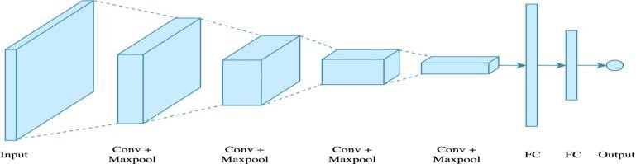

CNN model

**A. Modules Description**

**A.1 Data Collection:**

This module deals with collecting images from various sources. Two sets of images were collected, one which contains forest fires and other images that do not contain a fire in the forest. Apart from these, few other images that have a fire but do not classify under forest fire have been taken to make the model predict them as a negative image (no forest fire) to show that the model is predicting properly.

**A.2 Training the model**

Convolutional Neural Networks have been used for prediction. Different layers are used such as,

**i )Convolutional layer**

This layer takes the input image and scans the entire input image a few pixels at a time by using a filter and computes the dot product between the filter and the image which produces an output [14]. This filter decides how many pixels are to be scanned each time. If the filter size is 3*3 then 3*3 pixels of the input image will be scanned first, then the filter moves to scan the next set of 3*3 input image pixels. N number of pixels can be used.

**ii )Pooling layer**

It reduces the amount of information produced for each feature by the convolution layer and retains the most relevant information. The goal of this layer is to minimize the computation done in the network and also the number of parameters.

**iii )Fully connected layer**

The fully connected layer comprises of the fully connected input layer, which flattens the outputs generated by the previous layers followed by which they convert them into a one-dimensional vector that can be used as an input for the next layer (fully connected output layer) . This layer generates the final probabilities to determine a class for the image.

**IV CONVOLUTIONAL NEURAL NETWORKS**

Convolution Neural Network, a widely used methodology in deep learning is used for the classification and identification of the picture. It takes an input image, assigns value to various attributes such as the weights and biases of the image, and forward propagates through the network and produces an output. This obtained output is then back propagated when in cases of errors, where the weights and biases are updated step by step until the desired output is got. In CNN, pre-processing is much lower than the other classification algorithms. CNN can learn filters/characteristics with appropriate methods unlike primitive ones that require hand engineering of filters. It can identify important features automatically without supervision .

A basic CNN architecture has the following layers:

**I )INPUT LAYER**

The two-dimensional input layer stores the raw image data with the required size in multiples of 16, 32, 64, 224, 256, etc. for both height and width for effective usage of memory fields.

**ii )CONVOLUTIONAL LAYER**

If the image is loaded into the input layer, the following hidden layers are connected back to the previous layers . This follows a convolution operation, which is a combination of two functions. This demonstrates how one feature modifies the form of others. The images are interpreted in the method as a type of a multi-dimensional matrix.

**iii) POOLING LAYER**

This layer performs down sampling operations on all dimensions (width and height), reducing the number of required parameters and thus reduces the probability of over fitting. Max pooling, Average pooling, and Global pooling are the commonly used pooling types.

**iv) FULLY CONNECTED LAYER**

Neurons in the Fully Connected layer are connected to all the activations in previous layers as in ordinary neural networks. It uses the SoftMax activation function for classifying input images into various classes.

**Weights and Biases**

Each neuron in the neural network determines the output by adding a specific function to the input values from the previous layer. The function that is added to input values is Calculate by the vector of weights and by the bias (usually real numbers) [3]. Learning progresses in the neural network by making iterative changes to the bias and weights.

**TYPES OF CONVOLUTIONAL NEURAL NETWORK.**

**LeNet-5**

LeNet-5 is the basic and simplest existing architectures among all the other Convolutional Neural Network architectures. The 5 suffixed to the LeNet is attributed to the 2 convolutional and 3 fully connected layers the network has. LeNet-5 has about 60,000 parameters [13]. This is the standard template used where there are convolution layers followed by pooling layers and finally one or more fully

connected layers.

**AlexNet**

AlexNet has gotten the name that it is one of the largest CNN to date. The network consists of about 60 million parameters roughly along with 5 convolutional and 3 fully connected

layers.

**VGG-16**

The VGG-16 was invented in the year 2014. It consists of 16 convolutional layers and a very uniform architecture. It is trained on 4 GPU’s for 3 weeks. The VGG-16 was invented by the Visual Geo etry Group (VGG). It has 13 convolutional and 3 fully connected layers. It uses smaller size filter.

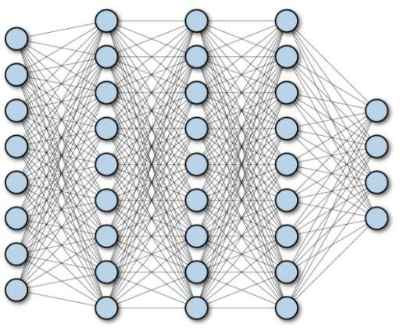

Connected layers in CNN

**FLOW CHART:**

# 

**ARCHITECTURE :**

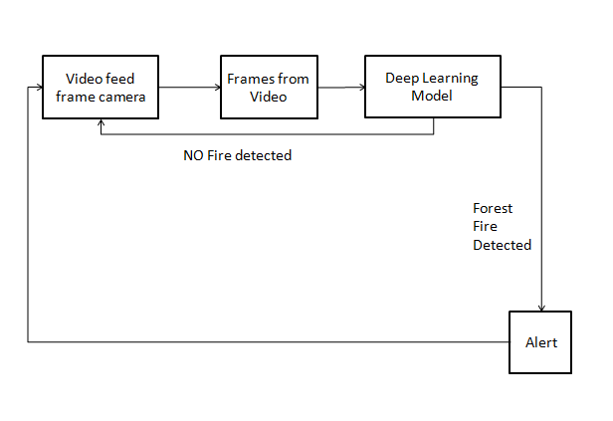

# RESULT :

There are various images in the testing collection for fire and non-fire, respectively. There are n number of images in all. These images were created from fire-related video and a small number of images from the internet .Using OpenCV, images from the dataset's two folders, 'Fire' and 'Non -Fire,' are read from the folders. Images are stored as NumPy arrays and have been resized to save space. The image array and class number are merged into a single list, which is then appended to a new list termed 'training data. 'The 'training data' has been mixed up. Separately, the image array and its classes are appended to two new lists. The image array is reshaped into a linear array from the list.

The batch size refers to the amount of samples that must be processed before moving on to the next step .changing the model's internal parameters One or more batches can be created from a training dataset. The number of times the learning algorithm is run is measured in epochs will go over all of the training data. The precision is excellent while the cost is inexpensive. Because of this, when the loss is reduced as the batch size is increased.

# OUTPUT:

# 

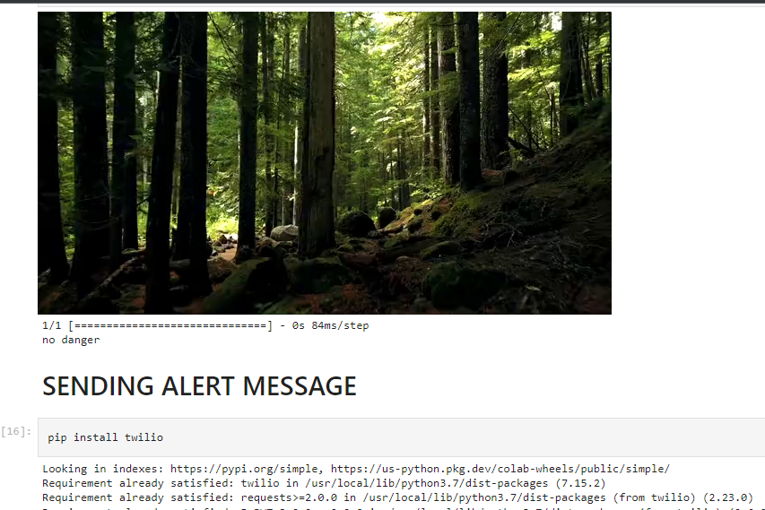

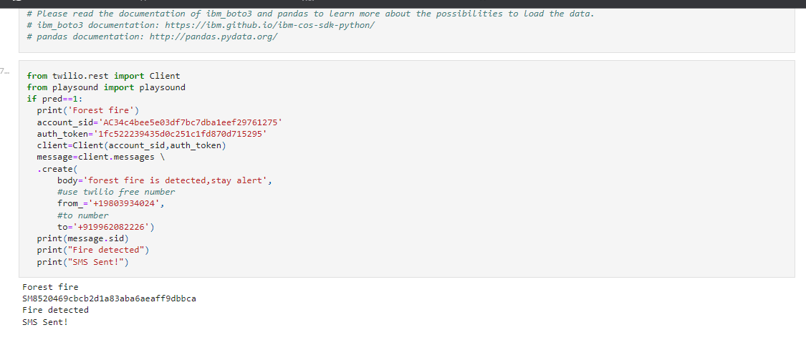

# CONCLUSION AND FUTURE SCOPE:

Fire is the most dangerous abnormal event because it can cause massive disasters, resulting in human, ecological, and economic losses, if it is not controlled quickly. Accidents involving fire can be discovered utilising the cameras. As a result, we suggested a CNN approach for camera-based fire detection. Under the supervision of cameras, our method can detect the fire. Furthermore, by fine-tuning datasets, our suggested approach balances the accuracy of fire detection with the size of the model. We were able to achieve a 95 percent accuracy rate. These figures indicate that the model provides a more accurate prediction. We conducted trials with datasets gathered from fire recordings and compared them to our suggested method. Because of the CNN model's reasonable accuracy for fire detection, size, and rate of false alarms, the system can assist crisis management teams in quickly controlling fire disasters. As a result, substantial losses are avoided.This project is primarily concerned with the detection of fire scenarios that are being observed. Future research could concentrate on putting the model on a Raspberry Pi and employing the appropriate support packages to identify real-time fires by creating challenging and particular scene understanding datasets for fire detection methods and extensive trials.

# REFERENCES:

1. Punam Patel and Shamik Tiwari published a paper titled Flame Detection Using Image Processing Techniquesin International Journal of Image Processing in 2016.Volume 58 of the Journal of Computer Applications No.18.
2. Jareerat Seebamrungsat, Suphachai Praising, and Jareerat Seebamrungsat Panomkhawn Riyamongkol proposeda in 2014.Fire Detection in Buildings Using Wireless SensorsThird ICT International Conference on Image Processing IEEE Access Journal in Electrical Engineering Department Computer Science and Engineering.
3. Khan Muhammad and Jamil Ahmad published a paper in IEEE Transactions on Systems, Man, and

Cybernetics Systems in 2018 titled Efficient deep CNN based fire detection system and localization in video surveillance system.

[4]. In IEEE Explore Advances in Electrical and Computer Engineering, Abdulaziz and Young Im CHO proposed a paper titled An Efficient Deep Learning Algorithm for Fire and Smoke Detection with Limited Data.

[5] In 2016, Qingjie Zhang, Jiaolong Xu, Liang Xu, and Haifeng Guo presented a paper titled Deep Convolutional Neural Networks for Forest Fire Detection at the Aviation University of Air Force, Changchun's International Forum on Management, Education, and Information Technology Application.